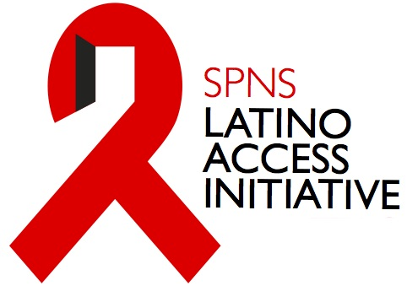
A Practical Guide for Implementing and Documenting the Integration of Transnationalism into Interventions of Outreach, Access and Retention for Mexican and Puerto Rican HIV-Positive Populations

Introduction

The goal of this guide is to provide Demonstration Sites with the methods for incorporating transnationalism into the various components of their interventions (e.g., outreach, social network testing, linkage and retention in care). In order to integrate transnationalism into their interventions, Demonstration Sites should have a clear understanding of the current context of the country or place of origin of their target population.

For clarification, we begin this guide by describing:

1) Transnationalism (TN)
2) Latino cultural elements
3) TN and Latino cultural elements as distinct concepts and as interacting concepts

In addition, we offer specific examples of how to integrate transnationalism into interventions. The examples are based on the ETAC’s understanding of transnationalism and cultural elements of Mexican and Puerto Rican populations and our work with each of the Demonstration Sites.

What is transnationalism?

Transnationalism refers to the varied means by which immigrants (and to some degree their children) maintain connections with their place of origin while continuing to establish themselves in their place of settlement (Basch, Schiller, & Blanc, 1994; Greder et al., 2009; Stone, Gomez, Hotzoglou, & Lipnitsky, 2005). A Transnational life includes practices and relationships that link migrants and their children with their place of origin, where these practices have significant meaning and are regularly observed (Smith 2005). Here are some key points for understanding:

- While living in the U.S., immigrants use their transnational connections as a primary point of reference that informs their cultural understandings and shapes those of their children (Carrillo, 2012). For example, their perspective about causes and treatment of a disease may be influenced by how these things are perceived in their country or place of origin.
- The frequency and intensity of an immigrants’ economic, political, and social engagement with their place of origin suggests that their lives and their identities may be developed in relation to more than one society (Tamaki, 2011). For example, their actions are likely influenced by their experiences in their country or place of origin, but also reflect their new life experiences in their current place of residency.

Transnationalism is best represented by the cross-border activities, practices and attachments of immigrants

Transnational practices can include informal and formal social, political, economic, cultural, and religious practices (Levitt & Jaworsky, 2007). Most immigrants will directly engage in selective transnational practices (i.e., willfully traveling to visit family) versus indirectly engaging in transnational practices such as shopping at a local Mercado because of proximity to their home.

These practices are usually in response to some event such as economic downturn in place of origin, or life cycle events such as marriage, birth of a child, illness, or climatic disasters (Levitt & Jaworsky, 2007). Most immigrants are occasional transnational activists. At some stages in their lives they are more focused on their place of origin while at others they are more involved in their place of settlement (Levitt & Schiller, 2004).

The most common forms of transnational practice that immigrants engage in to remain connected to their place of origin include:

Communication: A basic way in which immigrants maintain ties with their place or origin is through communication with relatives and/or friends and associates who live there (Murphy & Mahalingam, 2004). Available technologies such as email, texting and Skype have helped to increase the frequency of this activity.

Travel: Maintaining social and familial ties may also involve traveling back home to visit family and friends, or providing assistance to family and friends to visit immigrants in their host community (Murphy & Mahalingam, 2004).

Economic and Social Remittances:
- Money sent by migrants to their homeland may be used individually or collectively. This money may support family members who stay behind; fund small and large businesses; support public works and social service projects in the receiving communities (Levitt & Jaworsky, 2007).
- Social remittances (e.g., ideas, norms, practices, and identities) may flow back from place of settlement to place of origin.

Civic Engagement/Politics: Migrants’ political transnational practices can include a variety of activities such as electoral participation, membership in political associations, parties, or campaigns in two different countries, or engaging in protest movements (Levitt & Jaworsky, 2007).

In addition to these cross-border practices, there are activities and spaces in their host community that allow immigrants to remain connected to their place of origin. These transnational activities and spaces may include social and commercial venues such as neighborhood associations, churches, restaurants, bars, or barber shops, or activities such as participating in local soccer teams.

What influences transnational practices?

Length of time in the U.S.: Greder et al. (2009) found that Latino immigrants who most engaged in transnational activities were also those who had lived in the United States for the shortest amount of time. While Latinos who had lived in the U.S. for the longest amount of time had the lowest amounts of engagement in transnational activities.

Generational impact: Transnational practices and attachments have been and continue to be widespread among the first generation, but few researchers think these ties persist among subsequent generations. Transnational activities will not be central to the lives of most of the second or third generation, and they will not participate with the same frequency and intensity as their parents. But the same children who never go back to their ancestral homes are frequently raised in households where people, values, goods, and claims from somewhere else are present on a daily basis (Pries 2004).

Why is Transnationalism relevant for this initiative?

More and more research is investigating and demonstrating the impact of transnationalism on the health and healthcare-seeking behaviors of immigrant populations (Greder et al., 2009; Kessing et al., 2013; Murphy & Mahalingam, 2004). The impact in some cases may be negative. However, some studies have also revealed a benefit of transnationalism on life satisfaction or quality of life of immigrant populations. This initiative provides an opportunity to rigorously assess the impact of transnationalism on access to and retention in HIV care among Mexican and Puerto Rican HIV-positive populations. We can assess, as part of this initiative, whether transnationalism is a facilitator or barrier to accessing and remaining in HIV care. This is the first attempt to systematically evaluate the impact of transnationalism on HIV care.

What are Latino Cultural elements in the context of this initiative?

- Simpatía – The value of kindness, warmth, and pleasantness in relationships, even in stressful situations.
- ‘Familismo’ – The value of having a strong orientation to the family as it relates to the self.
- Norms around gender and sexuality e.g. Machismo– providers of the family, holders of integrity of family and honor of family members. Marianismo – The value of being a dedicated and supportive daughter, sister, mother or wife.
- Confianza – The value of building trust and intimacy in a relationship.
- Religiosity – can include definitions of religion that describe relationships between mind, body and spirit, and cultural labels such as sustos (fright), attaques de nervious (nervous crisis) and traditional healing practices via traditional healers (curanderas).

Transnationalism and Latino Cultural Elements: What are the differences, what are the intersections, and why does is it matter in the context of this initiative?

First, not all participants in this initiative will be transnational. Second, cultural elements might vary in how important they are to one participant versus another, but cultural elements may have broader impact on participants and influence their healthcare-seeking behavior.

Transnationalism and cultural elements are not interchangeable concepts

Transnationalism and traditional Latino cultural elements represent two distinct concepts; however, it is possible for transnationalism to intersect with cultural elements of Mexican and Puerto Rican populations.

How do we distinguish between transnationalism and cultural elements?

1. Transnationalism is represented by the practices that immigrant populations (and sometimes their children) engage in to remain connected to their country of origin. These practices, which include communication, travel, social and economic remittances, and civic engagement are described above.

2. Latino cultural elements are the values, beliefs and attitudes held by individuals of Mexican and Puerto Rican descent that reflect the society and culture of their place of origin.

3. We do not want to assume any degree of transnationalism or presence of Latino cultural elements based on stereotypes; thus, assessment of these two concepts with the study population is key for their effective use to engage participants

How do Transnationalism and culture relate to each other?

Although Transnationalism and traditional Latino cultural elements are distinct concepts, they are not exclusive of each other. The following three examples discuss how Transnationalism and cultural elements may interact with each other. We want to point out that there are an infinite number of scenarios in which Transnationalism and Latino culture play out and we hope you seek to understand this phenomenon and use it to your advantage to recruit, engage and maintain participants in your intervention.

You may want to consider the following mock situations. While we acknowledge that these scenarios are clear cut and artificial, they are meant to provide you with examples of how information on Transnationalism and culture may be used and interpreted.

A. Jose is a recent immigrant who migrated alone from Cuidad Juárez to Texas to work with his cousin. Jose lives alone but near his cousin and his family. Again, we do not assume about any feature of Jose’s life and thus we first start by stating that Jose can engage in zero, one, or many Transnational activities. It is only through talking with Jose to get his life history that we begin to unpack his practices regarding communication, social and political engagement, and civic activities with his family and cultural reference point that is Cuidad Juárez, Mexico.

B. At the same time, Jose can also value cultural elements such as machishmo, personalismo, etc… on a level of zero (he does not value these cultural elements) to very high level (cultural elements are central to his interactions with others, including medical providers, or is central to his decision making process).

Thus, the following scenarios could occur:

C1. High number of Transnational practices and Latino cultural elements - Jose engages in many transnational activities and has a very strong value system that is guided by cultural elements.
- Example 1 – Sandra feels an overwhelming desire to cancel or miss medical appointments in order to travel back to her country or place of origin (i.e. Transnational element) out of a having a sense of familismo (i.e., cultural element). This desire overrides her awareness of how important it is to attend her medical appointment.

C2. High number of Transnational practices and low levels of cultural elements –
- Example 2 – Javier failed to refill his antiretroviral therapy prescription last month. When the case manager called his cell phone, he revealed that he sent $200 dollars to his mother in Puerto Rico and had no money to cover his co-pay. Javier frequently sends money back to his family in Puerto Rico (Transnational element), communicates with them regularly via Skype (Transnational element), and follows the Puerto Rican economic crisis very closely as he is concerned about what will happen to his family should the economy collapse. However, the sense of family is driven more by his ethnic identity and identity as a Puerto Rican rather than having a strong sense of duty to his family, especially since there has been tension within the family since he disclosed to them his HIV status and sexual orientation. Javier is adamant about not being stereotyped as a macho male or putting the family above the self as he believes this diminishes his individuality. However, his Transnational activities are interfering with his ability to be adherent to his HIV treatment plan.

C3. Zero or very few number of Transnational practices and high levels of cultural elements -
- Example 3 – Ramon lives in East Los Angeles with his family. They moved to the U.S. a few years ago to escape the violence resulting from massive drug-trafficking and corruption happening in their home town. He has not traveled back to Mexico (transnational element) nor communicated with anyone in Mexico (transnational element), as all his family is here. He is close to his family (cultural element of familismo) and has shared with them is HIV-positive status. They have been nothing but supportive and caring (cultural element of simpatia) as he deals with this health issue.

C4. Zero or very few number of Transnational practices and does not value traditional Latino cultural elements.
- Example 4 – Javier left Puerto Rico after numerous arguments with his family surrounding disclosure of his HIV status and sexual orientation. He states that he does not want to communicate with them and is upset by the fact that many people tell him he needs to look out for his family when many of them were upset and abandoned him when he disclosed his status.

The previous examples illustrate the distinction between Transnationalism and traditional Latino cultural elements, however these concepts often overlap with each other as well. Please consider the following examples of how these concepts may occur simultaneously:

Example 1.

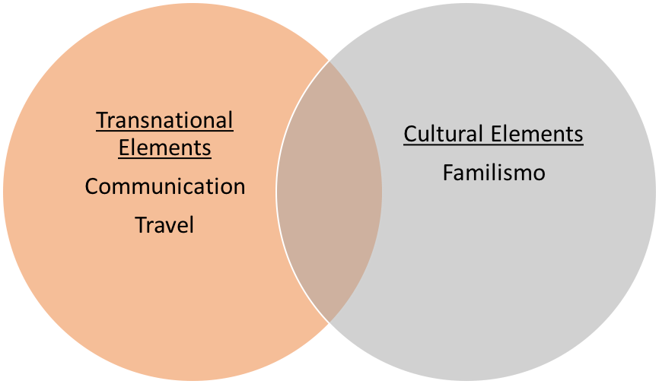
Overlap
Communication and/or travel between host and country of origin because of strong family ties (familismo)
Example 2.

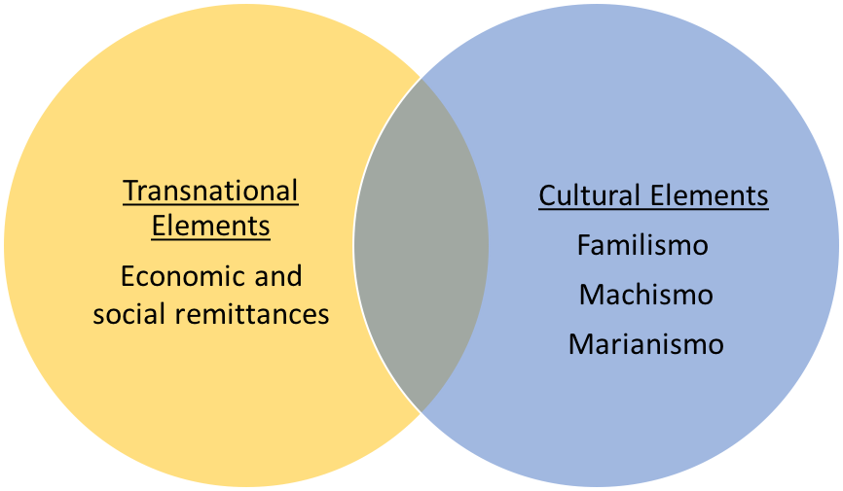
Overlap
Working many hours and sending economic remittances home due to a strong desire to help one’s family (familismo) or the belief that it is their job as a male provider (machismo) or dutiful daughter (marianismo)

Example 3.
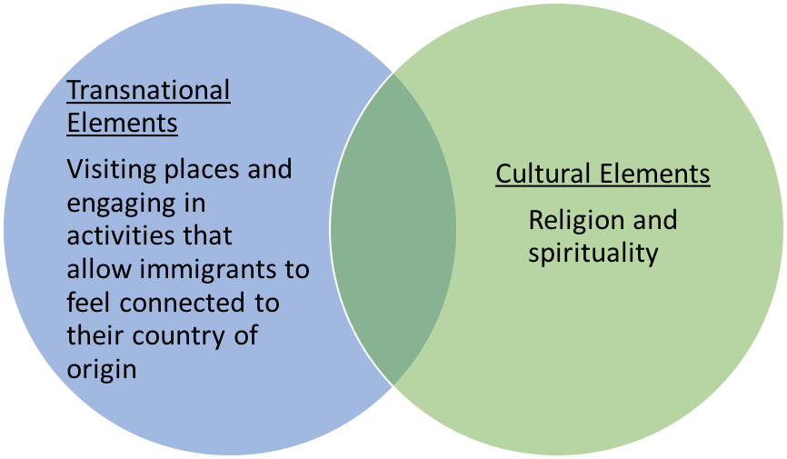
Overlap
Visiting a church where other immigrants connected to the host country attend (religion and spirituality)

Assessing Transnationalism and culture within the context of this Initiative
Using the Transnational Checklist developed by the ETAC is one approach to assessing Transnational practices and the presence of Latino cultural elements in your population of study.

Transnational Exploration Session including Transnational Checklist
The ETAC developed a Transnational Exploration Session tool for sites to use in their intervention, and it serves two purposes:

1) To better understand an individual’s level of transnationalism (i.e., How transnational is someone?);
2) To use this information about their transnational life as you engage with them throughout the intervention. These documents are included in Appendix A.

A Transnational Profile describes the extent to which individuals maintain connections with their place of origin, engage in transnational activities or view themselves as a transnational immigrant (i.e., an immigrant whose life involves connections across borders and whose identity is derived from their relationship with their place of settlement and place of origin). However, as a reminder, the purpose of the checklist is to NOT assume any cultural influence, but to rigorously assess whether or not there is a transnational or cultural influence.

The Transnational Profile will serve as a source of information that is incorporated into your intervention (as you see fit) as a new way of understanding facilitators and barriers to linkage and engagement in HIV care, ART adherence and clinical outcomes. This information can be incorporated at the individual, group or community level.

Integrating Transnationalism into intervention components
Sites should use the information gathered from the transnational profiles of their participants to determine the best way of integrating transnationalism into their intervention. In order to understand and integrate Transnationalism into the intervention components, interventionists should have some understanding of the current social, political, economic, and cultural factors at play in the country or place of origin of their participants. This understanding of the country or place of origin is essential to understanding the transnational experiences of participants.

Provided below are specific examples of how to integrate transnationalism into each type of intervention component. These examples are not exhaustive and may not apply to every site. They are meant to stimulate thought and inspire Sites to consider how they may incorporate Transnationalism into their unique interventions. For each type of intervention component, the ETAC has given examples of how to incorporate Transnationalism into that type of intervention followed by how this can be operationalized for documentation in the Site intervention manual.

Outreach
It is important to understand that immigrant populations may participate in activities or visit social spaces in their host community that make them feel connected to their place of origin. It is these transnational social spaces where interventionists may want to consider conducting their outreach activities. A few examples of social spaces that Puerto Rican and Mexican immigrants might visit include:

- Restaurants –particularly those run by members of participant’s country or place of origin
- Botánicas – frequented by Latinos or Latinos of a specific country or place of origin
- Bars – particularly those frequented by a specific Latino country or place of origin or where Latinos congregate
- Barber shops – particularly those catering to a specific Latino population
- Parks – frequented by members of a specific Latino population
- Churches – where congregations are made of Latinos or Latinos of a specific country or place of origin
- Neighborhoods – that are recognized by members of a specific Latino population

These places are where immigrants are likely to encounter and engage with other individuals from their place of origin or participate in activities or consume products that allow them to feel connected to their place of origin.

Social Network Outreach
To incorporate a transnational element into social network outreach, identify community leaders or individuals who are anchors in a social group that is united by their shared connection with their country of origin. This individual can conduct outreach to their friends, helping overcome barriers to care that might be specific to transnational practices. Coaching sessions for people conducting social network outreach should identify shared transnational practices among the friend group and explore their potential relationship to healthcare-seeking behaviors.

Social Media Outreach
To incorporate a transnational element into social media outlets, one could establish a Facebook, Twitter, or other population social media site fan page for the study, and list activities that are “Mexican” or “Puerto Rican-centric” focused, and advertise links to events that are occurring in the community in transnational social spaces (e.g., Mercado, or park where fútbol is played alongside community events). Another strategy is to post news articles about current events in the person’s home country and engage with a person’s civic or political interests. Lastly, one could post advertisements to conduct group or community events to discuss issues regarding communication and travel to and from their home country (albeit this may be a very sensitive issue).

Printed Materials
Consider using images or formats that draw on nostalgia for the country of origin. For example, using a comic book format, similar to those popular among youth and adults in Puerto Rico and Mexico, can help introduce information to a group of people who would not respond to a traditional pamphlet on HIV. The images within the comic book could draw on places and people popular in the country of origin.

Advertising (Radio and TV)
Rather than advertising an intervention as “a Latino-focused” intervention or indirectly advertising the intervention in Spanish as “for family and friends of the community,” perhaps be more direct by advertising the intervention as for the “Mexican community” or “Puerto Rican community.” To strengthen the sense of Transnationalism, advertisements can directly seek participants who travel, communicate, or who are knowledgeable about the politics of their country of origin.

Venue-Based Outreach
One strategy is to focus on venues that serve the migrant or recent immigrant communities, which utilizes the “social spaces” element of the transnational framework. One could start by developing confianza with the proprietors and patrons of these venues before beginning outreach efforts to demonstrate one’s commitment to serving the Latino community. The purpose of the venue-based approach is to utilize your outreach strategies in the social world that is more comfortable and common to recent Latino immigrants (assuming this is your target audience).

Community Events
Local community events have the advantage of drawing a large number of individuals to a common setting where contact and engagement with the study staff can occur. However, the purpose of conducting outreach at a community event is to develop a friendly and inviting space that all persons of all backgrounds would feel welcomed to explore. Thus, if a booth or table/tent was set up at a local community event for the study, one could utilize intriguing transnational-related questions to engage with attendees such as “do you travel back to Mexico to visit friends and family” or “are you interested in the health issues that affect Mexicans and Mexican Americans or Puerto Ricans” or “are you interested in learning about medical care in Mexico.” These questions that get at the heart of their identity, connecting their place of origin to their current residency may allow for better engagement. The purpose of asking opening questions with a transnational component is to engage with a person who may be engaging in transnational practices.

Operationalizing for intervention manuals
The challenge for the intervention manual is to operationally and conceptually define your activities, which may be fluid and change depending on the scenario. For example, for the social media approach you could state “the conceptual definition of the social media approach was to make the study present to online social media users who are more likely to use the internet via phone than on a computer. Thus, we operationally defined our social media component of the study as ‘we created X number of fan pages for the study on popular sites such as Facebook, Twitter, etc…that were mobile friendly’ which were monitored and updated weekly. A staff person was also responsible for responding to inquiries and the participant usage data (e.g., number of “likes” a page received) was coded and evaluated and team members met to discuss how we can improve engagement and our study presence on the social media site”. For your manual, it is helpful to define the concept of your study activities (what you are doing) and an operational definition of your activities (how you do it) in great detail to ensure your activities can be replicated.

Testing

Individual Testing
One potential strategy is to discuss with individuals Mexico’s universal coverage policy of ART for all Mexican nationals living with HIV. Thus, whether an individual travels to Mexico from the U.S. and vice versa, they learn that there are resources available to them in both countries. To further enhance your HIV strategy and integrate Transnationalism, you can choose to identify venues, events, and people/community groups where you believe Transnational activities occur (e.g., Mexico’s Independence Day Celebration Parade on September 16th).

Process of incorporating transnationalism
The first process of integrating Transnationalism into HIV testing is to identify barriers to testing and then identify how they may be linked to specific transnational activities. For example, one barrier is limited education about HIV treatment and lack of knowledge around HIV treatment and policies in the Continental U.S., the island of Puerto Rico and Mexico. In the Individual Testing Example, we are hypothesizing that if a recent immigrant learns that Mexico has a policy to provide ART to all its citizens upon a positive test, and that they can seek treatment in the U.S. at your site’s clinic, they feel that they have the medical resources available to them that will increase the likelihood to decide to get tested.

Operationalizing for intervention manuals
You can describe the following example in your intervention manual as such: “To enhance the likelihood that all individuals we approached agreed to get tested, we first reviewed the literature on barriers to seeking and agreeing to get an HIV test. Two major barriers cited in the literature were education and access to testing. Thus, we ensured that any stress that occurred with regards to the decision to get tested were allayed by providing information on both the U.S. and Mexico’s HIV treatment policy and by providing them with resources should they learn they are positive. We sought to test X number of individuals each month for Year 3 of the study and thus set up testing mobile units at community events led by Mexican-centric organizations. Our strategy was to reduce the stress of handling an HIV-positive diagnosis by ensuring access to treatment and to target events and settings that celebrated Mexico and its customs and holidays.”

Group-Level Interventions

Social Support
If your intervention provides social support using small groups, this may be a good opportunity to explore in more detail the transnational experiences and connections of members of the group. Having participants of similar background (i.e., Mexican or Puerto Rican) provides an opportunity for members of the group to support each other as they discuss and share their transnational experiences.

Process of incorporating transnationalism
A single small group session should be devoted to the concept of “identity” and how this impacts the way in which they deal with their HIV diagnosis. During the session, you can ask group members about the activities they engage in to remain connected to their country or place of origin (or that of their parents, if second generation) and if and how these connections, or lack of connections, impact their current HIV healthcare-seeking behaviors. For example, members may share that they feel isolated and alone because they cannot openly discuss their sexual orientation or HIV illness with family members back home. This open discussion can shed light on some of the positive and negative aspects of the connections between your participants and their country or place of origin. This small group discussion may also provide an opportunity for members to assist each other in addressing any negative impact these connections have on their health.

Operationalizing for intervention manuals
You can describe this small group session in your intervention manual in this way: A small group session will be conducted with participants to explore their “identity” (e.g., Puerto Rican, gay man, HIV-positive). As part of the discussion of identity, the group facilitator will lead a discussion about “level of connection with their country or place of origin.” This will be done by asking each member to describe how connected the feel to their country or place of origin and what they do to maintain that connection. The facilitator should ask participants about their participation in each of the main transnational practices (communication, travel and remittances) as part of this discussion. The facilitator should then ask participants about how this connection, or lack of, and participating in transnational activities impacts their current HIV health care behaviors. The facilitator should listen for both positive and negative influences (e.g., “I work so much to send money back home so I’m always tired and forget about taking my medications.” I talk with my family back home and they support me 100% and are always asking me if I’m taking care of myself. This helps me a lot.”) and have a group discussion to help members who may be having negative experiences because of their transnational practices. This discussion may be in the form of a brainstorming session to help members deal with some of the issues they are encountering.

Individual-Level Interventions
Individual-level interventions can be tailored around the specific experiences of the participant. The transnational exploration checklist is a useful tool in creating a transnational profile of individual clients. This will lead to a better understanding of how transnational elements may serve as barriers or facilitators to engagement and retention in HIV care.

Case Management Session
Maria has recently tested positive for HIV and has been enrolled into an ARTAS intervention. At their first meeting, the Linkage Coordinator utilizes the transnational checklist to create a transnational profile for Maria. The Linkage Coordinator informally assesses Maria’s level of transnationalism by asking her about the items included on the checklist. After the session, the Linkage Coordinator reviews Maria’s responses and includes his/her comments on the form. In reviewing Maria’s responses, the Linkage Coordinator identifies which elements serve as barriers and which serve as facilitators to Maria’s engagement and retention in HIV care. The Linkage Coordinator will then tailor future sessions with Maria so that these transnational elements are addressed in each session. In this case, Maria indicated that she has not disclosed her HIV status to her family in Puerto Rico. She often travels there for long stretches of time, during which she does not attend medical visits or take medication. The Linkage Coordinator identifies Maria’s travel back and forth from her home country as a barrier to care and tailors their sessions to focus on this issue.

Process of incorporating transnational and cultural elements
To incorporate transnationalism into this type of intervention, it is important to first identify which transnational elements are relevant to the client and whether they serve as barriers or facilitators to engagement and retention in care. One way to do this is to utilize the transnational exploration checklist, but there are many other ways this can be done. However, it is important that the interventionist document how the transnational profile of the client was developed, what transnational elements were observed, and how those elements impact the client’s HIV care. After reviewing the client’s transnational profile, the interventionist must decide on a method for incorporating that information into future sessions with the client, documenting strategies used and the client’s response.

Operationalizing for intervention manuals
You can describe this example in your intervention manuals in this way: “To enhance case management sessions so that transnational elements as they relate to the client’s HIV care are addressed, we will first conduct an informal interview with the client. During this interview, the transnational exploration checklist is utilized to assist in the creation of a transnational profile of the client. The Linkage Coordinator asks the client about their transnational experiences and beliefs by asking the questions on this checklist. Following the interview, the Linkage Coordinator reviews the client’s responses and documents additional observations they made during the interview. These notes are used to identify the barriers and facilitators to HIV care for the client. The Linkage Coordinator then chooses topics for each subsequent interaction with the client to address the barriers and facilitators to care identified in the client’s transnational profile.”

Summary Points

- Transnationalism and Latino cultural elements are two distinct concepts that may intersect with one another based on a client’s history and identity.

- Only through an assessment with a client can we begin to understand the details and the number of transnational activities a person engages in, as well as to what extent they value traditional Latino cultural elements.

- This practical guide provides examples of how you may tailor your intervention to persons with low and high number of transnational activities as well as to persons who do or do not value certain Latino cultural elements.

- Lastly, we provided details regarding the process of incorporating the transnational framework into your intervention and how you can operationalize your activities into your intervention manual.

- Investigating the Transnational framework, in conjunction with cultural elements, is a novel method to help engage Latinos in HIV access and retention in care research.

Appendix A

Transnational Exploration Session Outline

Purpose: The transnational exploration session serves two purposes:

- To understand an individual’s (project participant’s) Transnational Profile, and
- To use their Transnational Profile as a source of information that is incorporated into your intervention (in any way you would like) as a new way of understanding facilitators and barriers to linkage and engagement in HIV care, medication adherence and clinical outcomes.

- A Transnational Profile describes how an individual maintains connections with their country or place of origin and engages in transnational activities (described below). They may be considered as a “transnational” person. However, it is important to note that not all participants will maintain connections with their place of origin, or engage in transnational activities, or view themselves as a “transnational,” even if they engage in these activities.

- A person who engages in many transnationalism activities can be an immigrant whose daily life involves constant connections across borders and boundaries and whose identity is derived from their relationship with their place of settlement and place of origin. However, they can also be 2nd or 3rd generation status and engage in transnationalism activities. Thus, the idea of a person who is “transnational” should be used liberally.

Any of this information can be incorporated at the individual, group or community level.

Key Points:

1) Transnationalism is a process by which a person builds a social field that links their country or place of origin (e.g., Mexico, Puerto Rico) and their country/place of settlement (e.g., US/Texas, Chicago, New York, etc.).

- A social field is essentially a person’s life or social world. It is their daily activities, their neighborhoods or communities, their economic opportunities, their social and political behavior and how it affects them as a person and their group identity (e.g., Puerto Ricans living in the United States versus the Island).
- You want to consider their social field and how it is relevant in this population. That is, how does their social field influence their HIV care? People can engage in behaviors that connect them to two or more societies/identities or influence them whether these behaviors are intentional (e.g., watching or reading news in home country) or unintentional (e.g., shopping in mercados/bodegas that they are accustomed to). Some behaviors can also affect their HIV care? If possible, try to distinguish what behaviors they purposefully engage in that keep them connected to their culture of origin or what behaviors they engage in unintentionally but still connect them to their culture of origin, and how it impacts their HIV.
- Lastly, although the definition states linking a person’s “country of origin” to their current country of settlement, this detail can be exchanged with “culture of origin” in that they can be a second or third generation Mexican American/Puerto Rican and still engage in transnational activities.
2) Transnationalism components include:
- Points of Reference –What influences or from where do they derive their understanding about their personal health issues (place of origin, place of settlement, or both)?
- Social spaces – What settings are predominately used by people from their home country/setting (markets, clubs, community settings, church, or any other settings).
- Transnational Life – What are the significant practices/behaviors and relationships that are observed regularly that link individuals to their place of origin?
- Transnational Identity – To what extent their 1) culture, 2) ethnicity, 3) home country and/or 4) language is an extension of how they self-identify (i.e., view themselves? Additionally, how navigating two or more cultures or new settings (host and origin) changes how they view themselves?
- Transnational Practices – Please try to link the following to their health care and health behaviors and life experiences.
  - Ideas – How their current thoughts and actions are influenced or inked to their culture of origin/home country?
  - Norms – What are the standard practices, customs, habits, expected behaviors of their culture of origin/home country?
  - Economic remittances – Is any sum of money sent in payment for goods or services or as a gift to the country of origin? (e.g., family, political contributions, cultural events, etc.)
  - Social remittances – Are ideas, norms, practices, and identities that flow back from place of settlement to their place of origin?
  - Communication – Do they communicate with family, friends, organizations or any other individuals in their country of origin? How is communication achieved (e.g., phone calls, mail, e-mail, Skype, etc.).
  - Travel – How and when do they travel back to their country of origin? What are the reasons for the visit?
  - Political behavior – Do they keep up to date with the political events in their country of origin and/or place of settlement, be it local, state, or national? How do they engage in politics in their country of origin or place of settlement?
  - Time in the United States – How long have they been living in the Continental United States? If traveling back and forth from their country/place of origin, what is the longest period of time they spent in the U.S. and/or what do they travel patterns look like?
  - Generational status – What is their generational status?

2) Transnationalism is NOT what we think of as “traditional Latino cultural elements” (e.g., machismo, Marianismo, Personalismo, simpatia, familismo) nor is it acculturation. In other words, you must consider these “traditional Latino cultural elements” as working with or interacting with the Transnationalism process that you are integrating into your interventions.

Transnational Profile Checklist
Instructions: please use this checklist to informally assess how relevant these issues may be to the client. This information is to be provided to the interventionist (i.e., group leader, peer navigator, promotora, etc…) so that it can be integrated and used in the intervention. This checklist is to be used in an exploratory session, which offers a general sense of the individual’s personal transnational experiences, so as to begin working from the same narrative. This information is key to understand how (if at all) the transnational experience is affecting their HIV care.
Transnational Element | Response | Interventionist Comments
What is your cultural or country-specific point of reference?
- Where were you born?
Ethnic Identifier: How do you prefer to identify yourself? (it can be in more than one way). Mexican, Puerto Rican, Latino, Chicano, Hispanic, Nuyorican, etc…(use this information when completing the following questions).
Does being ___________ (ethnic identifier, e.g., Mexican) make it easier or harder to get, follow, ask questions about your HIV medical care?
What are some places that you frequently visit that remind you of your culture or country of origin or are frequented by other ______________ (ethnic identifier)?
How (if in anyway) does being from __________ (country/culture of origin) or viewing yourself as a ___________ influence the following:
- how you think about your health?
- how you think about your HIV status?
- how you think about your medical care? (Ideas)
- the actions you make about your health?
- the actions you make about your HIV?
- the actions you make about your medical care? (Norms)
Does your decision to send money back home interfere or help your
- health?
- HIV status?
- medical care?
Do you travel to and from your home country? Why or Why Not? Now, how do you think this helps or hurts your medical care?
How does communicating with your family back home motivate or interfere with your medical care for HIV?
How is the health care system here in the U.S. different from your place of origin?
Do you think the experience of being from outside the continental U.S./another country and traveling to the U.S. helps or makes it harder for you and your HIV care?
Do you think your HIV care is the same or different for people who are from __________? Can you explain?

(To be completed by intervention staff)
How would you summarize the client’s transnational profile in your own words: __________________________________________________________________________________________________________________________________________________________________________________________________________________________________________________________________ ________________________________
How does their transnational profile affect their HIV care (at any level): ____________________________________________________________________________________________________________________________________________________________________________________________________________________________________________________________________________________________________________________________________________________________________________________________________

References
- Smith, R. (2005). Mexican New York: Transnational lives of new immigrants. Univ of California Press.

- Basch L, Glick Schiller N, Blanc-Szanton C, eds. 1994. Nations Unbound: Transnational Projects, Postcolonial Predicaments, and Deterritorialized Nation-States. London: Gordon & Breach
- Greder K, et al. (2009). Exploring relationships between transnationalism and housing and health risks of rural Latino immigrant families, Family & Consumer Sciences Journal, 34(2), 186-206
- Kessing L, Norredam M, Kvernrod A, et al. (2013). Contextualising migrants' health behaviour - a qualitative study of transnational ties and their implications for participation in mammography screening. BMC public health, 13, 431-.
- Levitt, P & Jaworsky N. (2007). Transnationalism migration studies: past developments and future trends. Annual Review of Sociology, 33, 129-156.
- Levitt P, Glick Schiller N. 2004. Conceptualizing simultaneity: a transnational social field perspective on society. Int. Migr. Rev. 38:1002–39
- Murphy, E J, & Mahalingam, R. (2004). Transnational ties and mental health of Caribbean immigrants. Journal of immigrant health, 6(4), 167-78.
- Pries L. 2004. Determining the causes and durability of transnational labour migration between Mexico and the United States: some empirical findings. Int. Migr. 42:3–39
- Stone, E., Gomez, E., Hotzoglou, D., & Lipnitsky, J. Y. (2005). Transnationalism as a motif in family stories. Family Process, 44(4), 381–398.
- Tamaki, E. (2011). Transnational Home Engagement among Latino and Asian Americans: Resources and Motivation. The International migration review, 45(1), 148-173.
- Carrillo, H. (2012) Sexual Culture, Structure, and Change: A Transnational Framework for Studies of Latinoa/ Migration and HIV. In K. Organista (ed), HIV Prevention with Latinos: Theory, Research, and Practice. New York: Oxford University Press, 41-61.
- Alcántara C et al. (2014). Transnational ties and past-year major depressive episodes among Latino immigrants. Cultural Diversity and Ethnic Minority Psychology. doi: 10.1037/a0037540

- Koehn PH. (2006). Globalization, migration health, and educational preparation for transnational medical encounters. Globalization and Health. doi: 10.1186/1744-8603-2-2

